Module 4

Wait

The wait block is very useful to perform actions and wait for the robot to interact with an object. The block can be found as shown below.

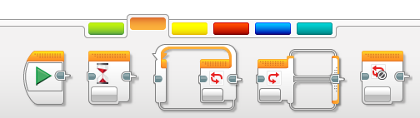

By default it is set to wait for one second.

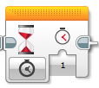

However the block is much more useful than just waiting for time to pass. Open the Menu to see all the possible things you can wait for.

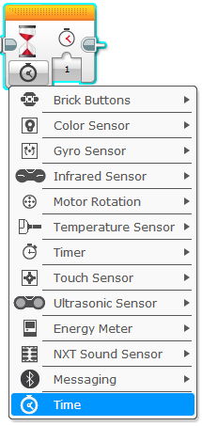

# Activity 1 – Stop at Angle

## Tutorial

Open up and complete the tutorial project Robot Educator 🡪 Basics 🡪 Stop at Angle.

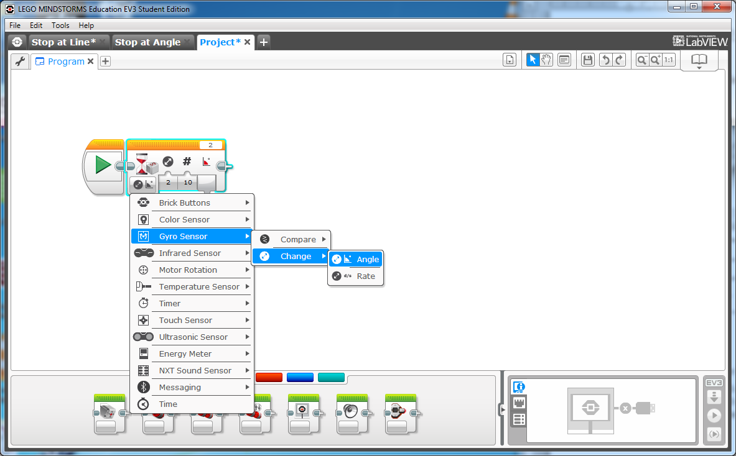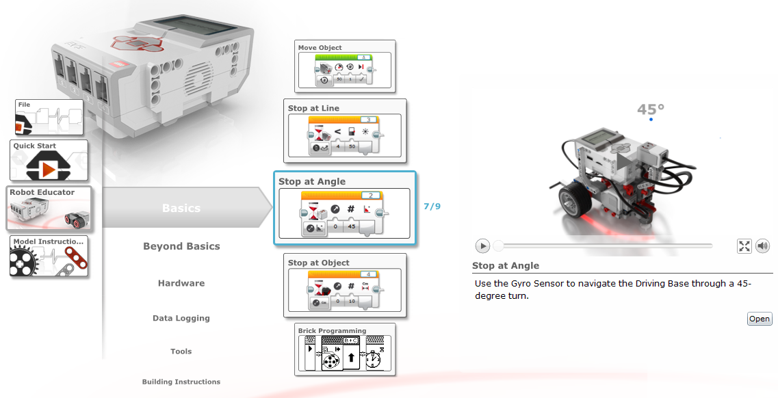

Make sure your wait block in the correct mode.

## Challenge

Now that you have had some practice, try this problem.

1. Turn to 180 degrees
2. Turn to 500 degrees
3. Turn **Left** to 45 degrees

*Hint: Don’t forget to change the numbers on your move block.*

# Activity 2 – Stop at a Line

## Tutorial

Open up and complete the tutorial project Robot Educator 🡪 Basics 🡪 Stop at Line.

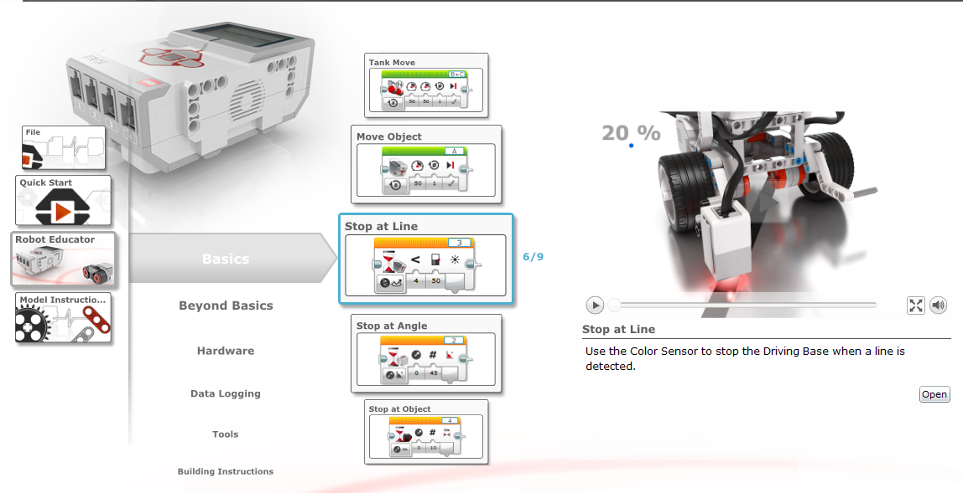

## Challenge

Now that you have had some practice, try this problem.

1. Move forward to the line.
2. Stop at the line.
3. Turn around (Use the Stop at Angle activity technique).
4. Go back towards the starting position.

*Hint: It doesn’t matter if your robot doesn’t stop in the same place it started.*

# Activity 3 – Stop at a Object

## Tutorial

Open up and complete the tutorial project Robot Educator 🡪 Basics 🡪 Stop at Object.

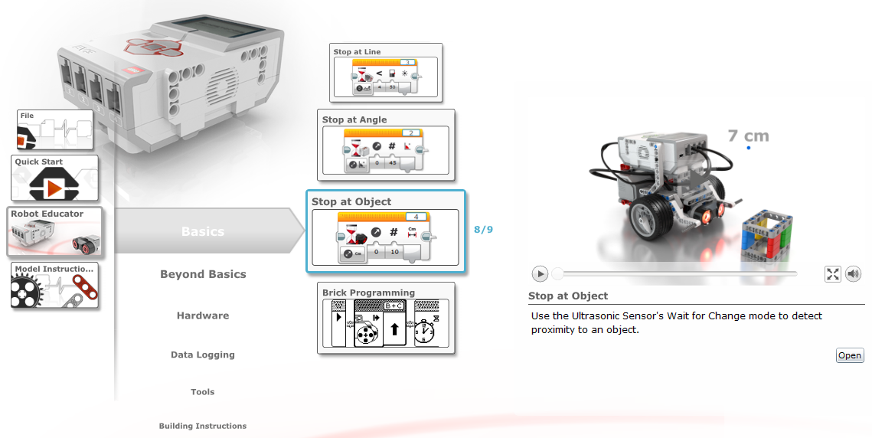

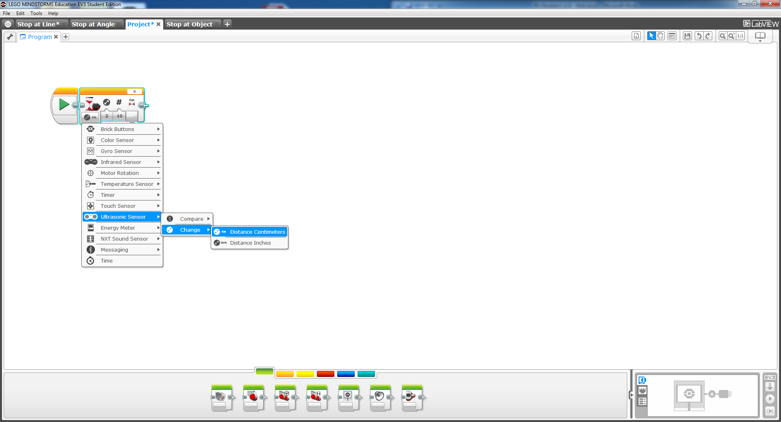Make sure your wait block in the correct mode.

The first wait block is waiting for a decrease of 11cm and the second is waiting for an increase of 6 cm.

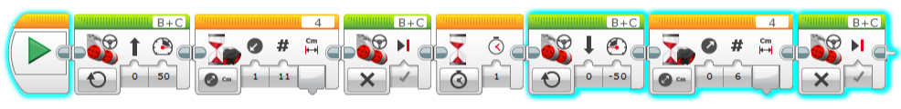

## Challenge

Now that you have had some practice, try this problem.

1. Change your mode to “Compare in cm”.
2. Stop 6 cm in front of the object, no matter where you put the robot.

*Hint: The robot should be waiting for a value less than the number you tell it.*